Database Assignment 1

Note : Use Emp, dept and salgrade table

1. To list all records with sal > 2000 and comm>200

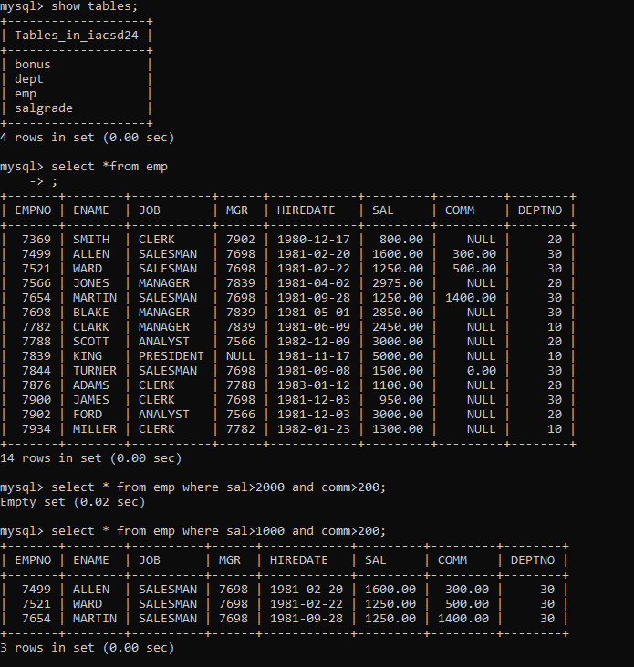

2. To list all record with job=’Clerk’ or sal>2000

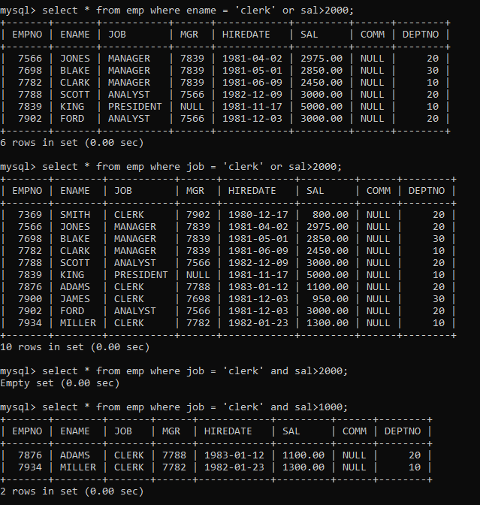

3. To list all the record with sal=1250 or 1100 or 2850

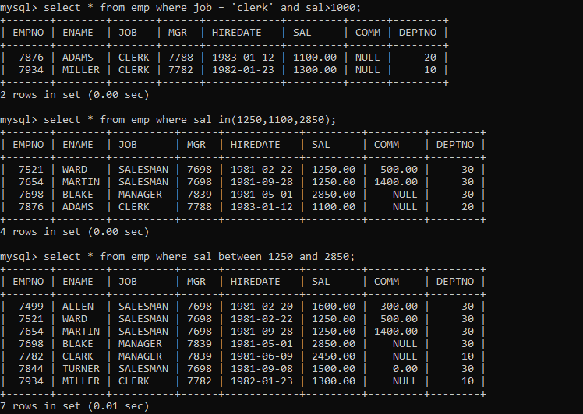

4. To list all employees with sal>1250 and <2850

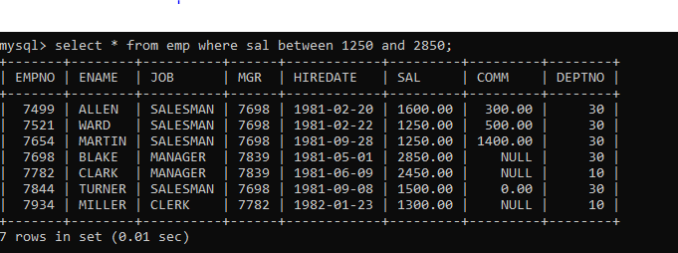

5. To list all employees with name ends with AS

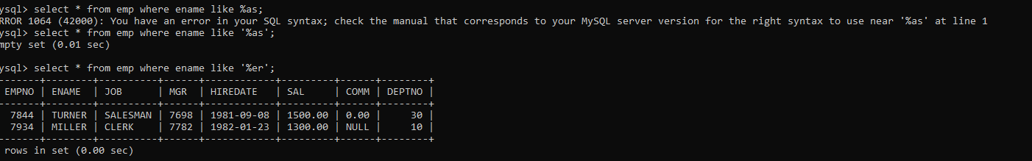

6. To list all employees with job starts with C and ends with K

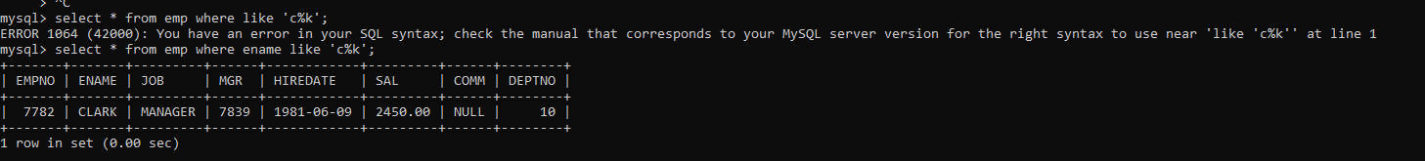

7. To list all employees with job contains L at third position and M at third last position

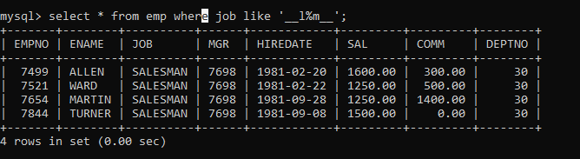

8. To list all the record with sal not equal to 1250 or 1100 or 2850

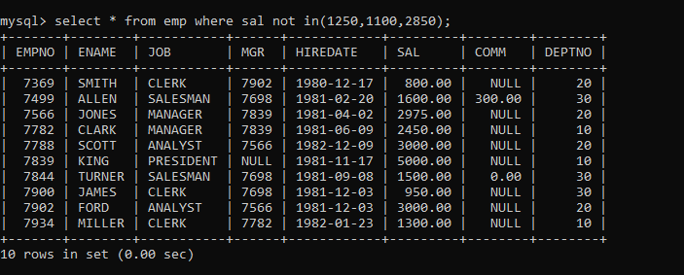

9. To list all employees with sal not >1250 and <2850

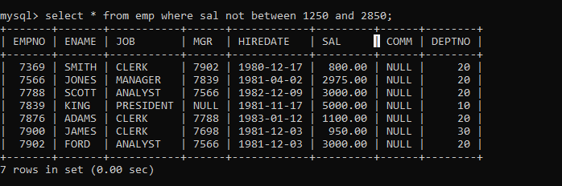

10. To list all employees with job starts with C , E at 3rd position and ends with K

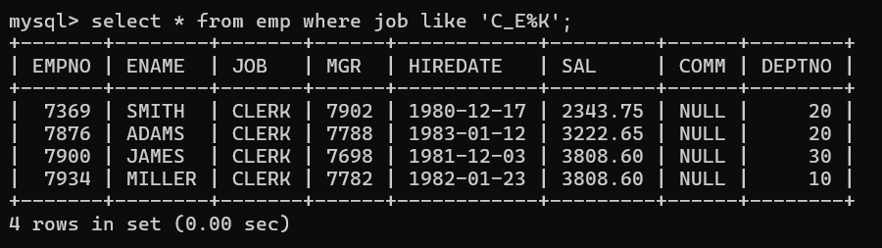

11. To list all rows with comm is null

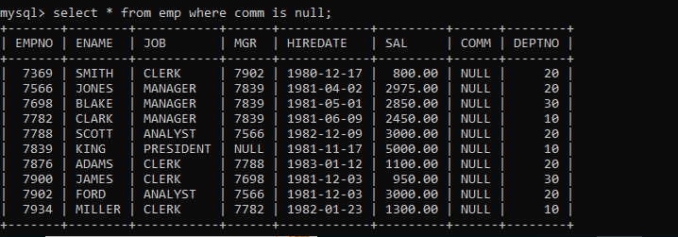

12. To list all employees with sal is null and name starts with ‘S’

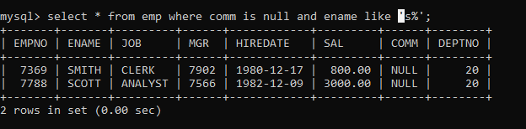

13. To list all employees with job contains 5 characters

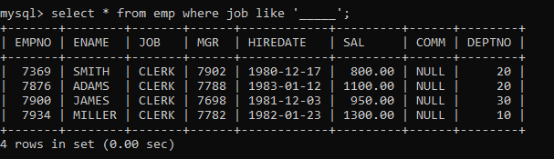

14. To list all employees with name contain ‘A’ at 1 position and job

Contains 5 characters

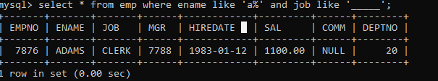

Q2. Solve the following

1. Retrieve the details (Name, Salary and dept no) of the emp who are working in

department code 20, 30 and 40.

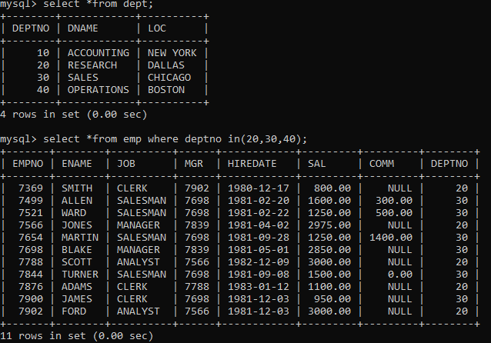

2. Display the total salary of all employees . Total salary will be calculated as

sal+comm+sal*0.10

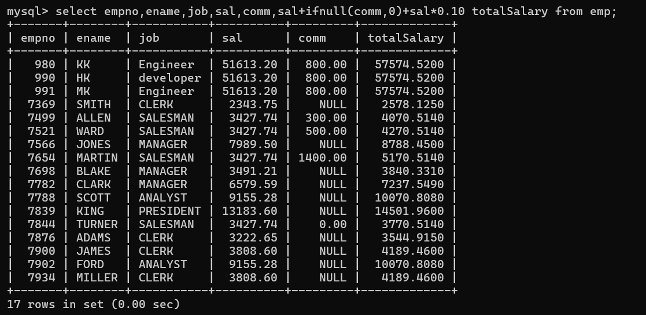

3. List the Name and job of the emp who have joined before 1 jan 1986 and whose

salary range is between 1200and 2500. Display the columns with user defined Column

headers.

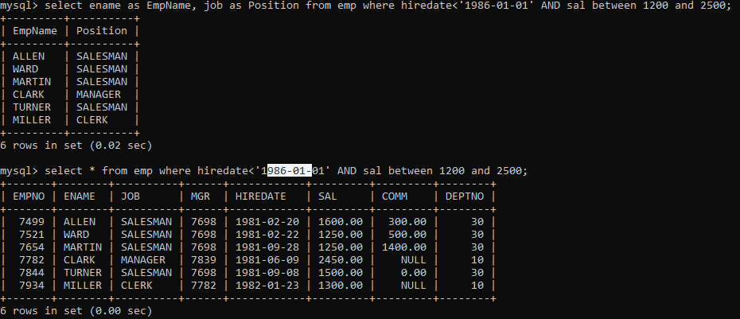

4. List the empno, name, and department number of the emp works under manager

with id 7698

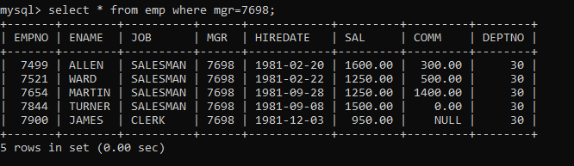

5. List the name, job, and salary of the emp who are working in departments 10 and

30.

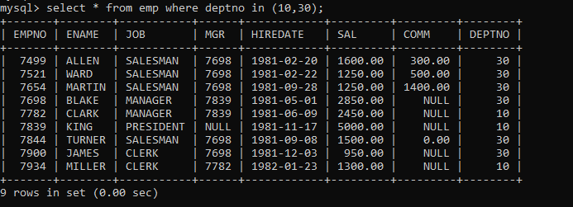

6. Display name concatenated with dept code separated by comma and space. Name

the column as ‘Emp info’.

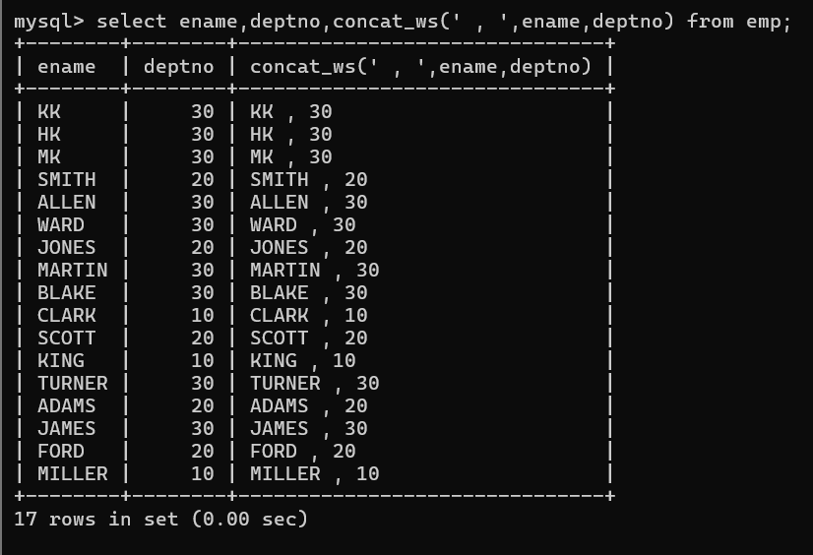

7. Display the emp details who do not have manager.

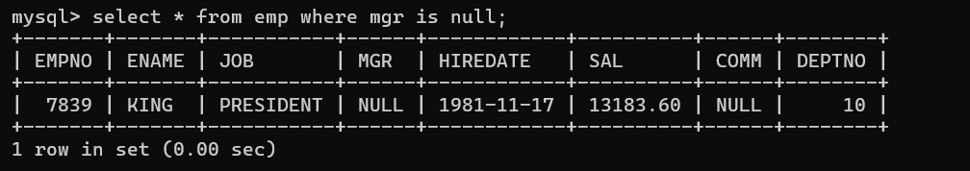

8. Write a query which will display name, department no and date of joining of all

employee who were joined January 1, 1981 and March 31, 1983. Sort it based on date of

joining (ascending).

select ename,deptno,hiredate

from emp

where hiredate between '1981-1-1' and '1983-3-31'

order by hiredate

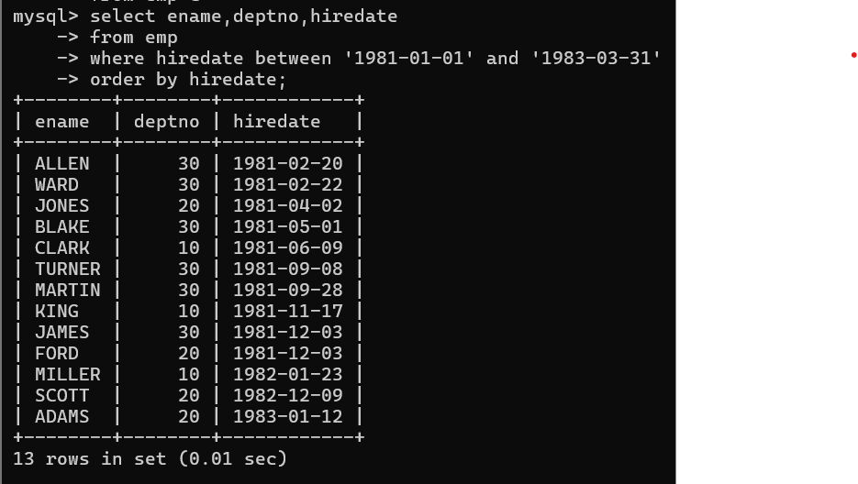

9. Display the employee details where the job contains word ‘AGE’ anywhere in the Job

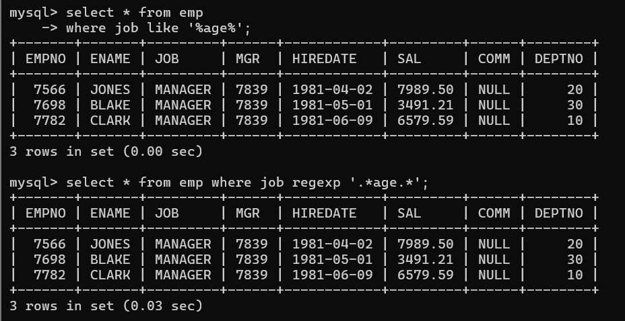

11. List the details of the employee , whose names start with ‘A’ and end with ‘S’ or

whose names contains N as the second or third character, and ending with either ‘N’ or ‘S’.

select *

from emp

where ename like ‘A%S’ or ename like ‘_N%N’ or ename like ‘_N%S’ or ename like ‘__N%N’

or ename like ‘__N%S’

or

select *

from emp

where ename REGEXP ‘^A.*S$| ^..?N.*[NS]$‘

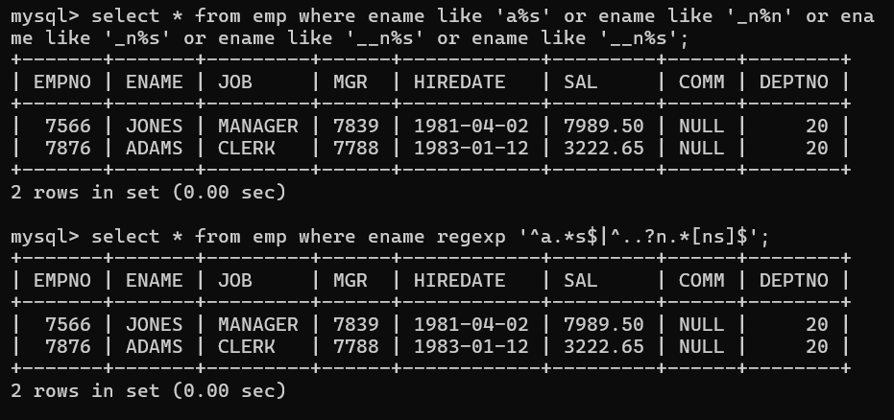

12. List the names of the emp having ‘_’ character in their name.

